**[File sharing between host and container (docker run -d -p -v)](http://www.bogotobogo.com/DevOps/Docker/Docker_File_Share_between_Host_and_Container.php)**

**docker run -v**

Though we executed docker run commands with various argument combinations in the previous chapter ([More on docker run command (docker run -it, docker run --rm, etc.)](http://www.bogotobogo.com/DevOps/Docker/Docker_Run_Command.php)), docker run was not doing useful operations.

So, in this chapter, we'll learn more about docker run commands that doing more useful things.

We're going to run docker run command with -v argument:

k@laptop:~$ docker run -help

Usage: docker run [OPTIONS] IMAGE [COMMAND] [ARG...]

Run a command in a new container

-v, --volume=[] Bind mount a volume (e.g., from the host: -v /host:/container, from Docker: -v /container)

--volumes-from=[] Mount volumes from the specified container(s)

Let's do it:

k@laptop:~$ docker run -it --rm -v /home/k/myDocker:/k busybox sh

/ # cd k

/k # ls

/k # touch bogotobogo.txt

/k # exit

k@laptop:~$ cd /home/k/myDocker

k@laptop:~/myDocker$ ls

bogotobogo.txt

k@laptop:~/myDocker$ ls -la

total 8

drwxrwxr-x 2 k k 4096 Nov 22 12:16 .

drwxr-xr-x 89 k k 4096 Nov 22 12:15 ..

-rw-r--r-- 1 root root 0 Nov 22 12:16 bogotobogo.txt

Here in the argument, we're binding a folder in our local machine (/home/k/myDocker) with the folder in Docker container (k) so that they can share files:

-v /home/k/myDocker:/k busybox

As we can see from the output, the two folders are sharing a file that was created in the container. Also note that the permissions on the file, "bogotobogo.txt". It was created with "root" user permission. A special care should be given so as not to the permission things not to be messed up. There is a way to work around it:

k@laptop:~/myDocker$ sudo rm bogotobogo.txt

[sudo] password for k:

k@laptop:~/myDocker$ id k

uid=1000(k) gid=1000(k) groups=1000(k),4(adm),24(cdrom),27(sudo),30(dip),46(plugdev),108(lpadmin),124(sambashare),1005(svn),131(docker)

k@laptop:~/myDocker$ docker run -it --rm -v /home/k/myDocker:/k -u 1000:1000 busybox sh

/ $ cd k

/k $ touch bogotobogo.txt

/k $ ls

bogotobogo.txt

/k $ exit

k@laptop:~/myDocker$ ls

bogotobogo.txt

k@laptop:~/myDocker$ ls -la

total 8

drwxrwxr-x 2 k k 4096 Nov 22 12:28 .

drwxr-xr-x 89 k k 4096 Nov 22 12:15 ..

-rw-r--r-- 1 k k 0 Nov 22 12:28 bogotobogo.txt

This way we can keep the ownership remains the same. Since this may cause another problem, we need to be very careful when we mount the volume to the container.

**docker run with port argument**

In this section, we'll learn how to use port argument, -p, with Nginx web server.

k@laptop:~$ docker run -help

Usage: docker run [OPTIONS] IMAGE [COMMAND] [ARG...]

Run a command in a new container

-d, --detach=false Detached mode: run the container in the background and print the new container ID

-P, --publish-all=false Publish all exposed ports to the host interfaces

-p, --publish=[] Publish a container's port to the host

format: ip:hostPort:containerPort | ip::containerPort | hostPort:containerPort | containerPort

(use 'docker port' to see the actual mapping)

We'll map container's port 80 to the host.

k@laptop:~/myDocker$ docker run -d -p 80 nginx

Unable to find image 'nginx' locally

nginx:latest: The image you are pulling has been verified

f10807909bc5: Pull complete

f6fab3b798be: Pull complete

d21beea329f5: Pull complete

04499cf33a0e: Pull complete

34806d38e48d: Pull complete

4cae2a7ca6bb: Pull complete

23f7e46a4bbc: Pull complete

9dfd3384699f: Pull complete

475220486d0e: Pull complete

30bb1926e17f: Pull complete

ef45dc12127b: Pull complete

e426f6ef897e: Pull complete

511136ea3c5a: Already exists

Status: Downloaded newer image for nginx:latest

72780dcf6c7ea4e14e497810722d297a8f4f8157099ea122e9345b76b0bab822

k@laptop:~/myDocker$ docker ps

CONTAINER ID IMAGE COMMAND CREATED STATUS PORTS NAMES

72780dcf6c7e nginx:latest "nginx -g 'daemon of 7 seconds ago Up 5 seconds 443/tcp, 0.0.0.0:49153->80/tcp condescending_elion

We did docker run in detached mode (-d) meaning making it running in background. As we can see from the PORT column in the output docker pscommand, the Nginx on Docker container mapped port 80 of Nginx to 49153 port of host. So the port 49153 on local machine will go to port 80 of Docker Nginx.

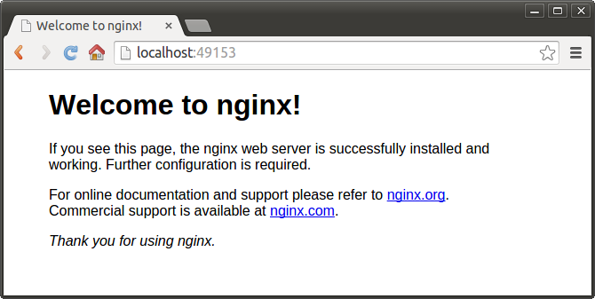

If we want to specify the exact port on host, suppose 8099, we can do it:

k@laptop:~/myDocker$ docker ps

CONTAINER ID IMAGE COMMAND CREATED STATUS PORTS NAMES

72780dcf6c7e nginx:latest "nginx -g 'daemon of 23 minutes ago Up 23 minutes 443/tcp, 0.0.0.0:49153->80/tcp condescending_elion

Stop the container and remove it:

k@laptop:~/myDocker$ docker stop 72780dcf6c7e

72780dcf6c7e

k@laptop:~/myDocker$ docker rm 72780dcf6c7e

72780dcf6c7e

Then, specify the host port number (8099) we want to use:

k@laptop:~/myDocker$ docker run -p 8099:80 -d nginx

5444b242bf8d1f01229e11e0838ce11e918df03a038540b5c2dd66ec52023f08

k@laptop:~/myDocker$

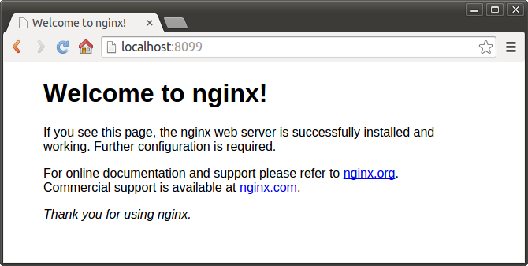

We can always check how the ports are mapped:

k@laptop:~/myDocker$ docker ps -a

CONTAINER ID IMAGE COMMAND CREATED STATUS PORTS NAMES

5444b242bf8d nginx:latest "nginx -g 'daemon of 5 minutes ago Up 5 minutes 443/tcp, 0.0.0.0:8099->80/tcp mad_ptolemy

**docker run -e : passing environment variable**

Occasionally, we may need to passing in environment variable to docker run with -e argument.

k@laptop:~/myDocker$ docker run -it --rm -e DOCK_VAR=BOGOTOBOGO busybox sh

/ # echo $DOCK_VAR

BOGOTOBOGO

/ # exit

Passing in environment variables is useful when we deal with MySQL or password etc.

**The 2nd sample : docker run -v**

Suppose we have a file written in **go**, but we do not have the compiler. So, we decided to use Docker's **go** image, run the container, and compile it. Since we can share a file between host and container, after the compile, we get the executable on our host machine.

Here is our **go** file:

k@laptop:~/golang$ cat HelloWorld.go

package main

import "fmt"

func main() {

fmt.Println("Hello World!");

}

**docker run**:

k@laptop:~/golang$ docker run -it --rm -v $(pwd):/go -u 1000:1000 golang:latest go build -o HelloWorld.out

Unable to find image 'golang:latest' locally

latest: Pulling from golang

902b87aaaec9: Pull complete

...

golang:latest: The image you are pulling has been verified. Important: image verification is a tech preview feature and should not be relied on to provide security.

Digest: sha256:2d94c1307f3ed7f679141f392ce545673397fd51e9395fcefe96500b610b68bb

Status: Downloaded newer image for golang:latest

k@laptop:~/golang$ ls

HelloWorld.go HelloWorld.out

Now, we have an executable **HelloWorld.out** on our local host machine. Let's run it:

k@laptop:~/golang$ ./HelloWorld.out

Hello World!

Note that we were able to compile and run the **go** file even though **go** is not installed on our machine!

Note also that the **owner:group** is **k:k** because we used **1000:1000** in the **docker run** command:

k@laptop:~/golang$ ls -la

total 2320

drwxrwxr-x 2 k k 4096 Aug 19 23:39 .

drwxr-xr-x 129 k k 4096 Aug 19 23:19 ..

-rw-rw-r-- 1 k k 75 Aug 19 23:21 HelloWorld.go

-rwxr-xr-x 1 k k 2361088 Aug 19 23:39 HelloWorld.out